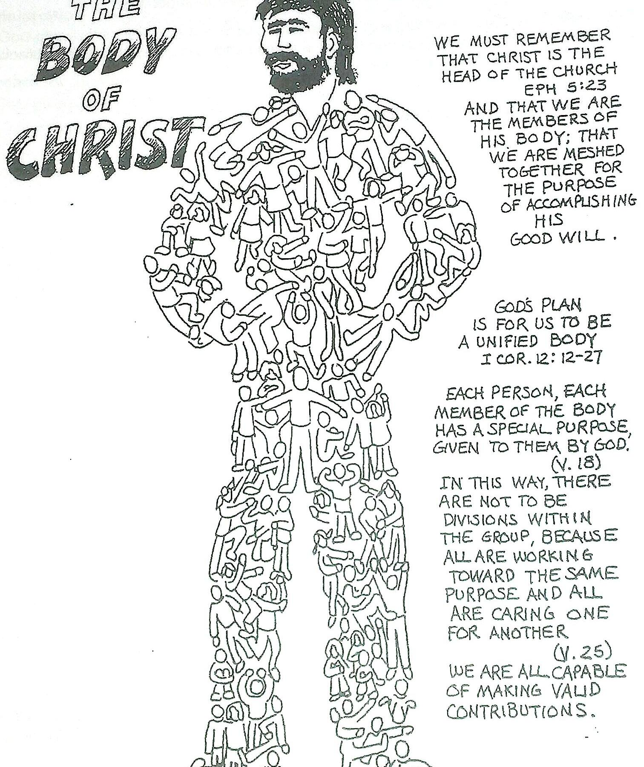

Can you colour in this picture, or draw your own?
What are some of the ways YOU can help as part of the CHURCH, the Body of Christ?

