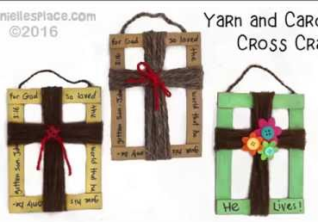

What you will need:
Cardboard, Scissors, Wool, Glue, Paint or markers or similar to colour/write
You could use decorative Items such as Buttons, Beans, Flowers, etc.
How to Make the Cross Craft:
1. Cut 2 long and 2 shorter cardboard strips (roughly 2cm wide, 15cm & 10cm long)
(Or you could cut a rectangle out of a cardboard box eg cereal or delivery box!)
2. Glue the strips together to form a rectangular frame.
3. Cut some wool into roughly 4m and 3m pieces.
4. Paint or decorate the frame with paint markers or acrylic paint.
5. Wind the longer piece of wool around the middle of the long side of the frame. Wind the shorter piece around the side to form a cross shape.
6. Tie in the middle nearer to the top where the wool crosses to make the cross shape.
7. Write a Bible verse around the edge of the frame. You could use this or another.
“Whoever wants to be my disciple must deny themselves
and take up their cross and follow me.”
“Take up your cross and follow me”
(Matthew 16:24)

