Interactive Nativity Advent Countdown - Follow the Star (with 25 Activity Ideas)
I've seen some beautiful Advent ideas & calendars online, but this year wanted to create one that would suit Minnie's current interests & at the same time help her explore the real meaning of Christmas.

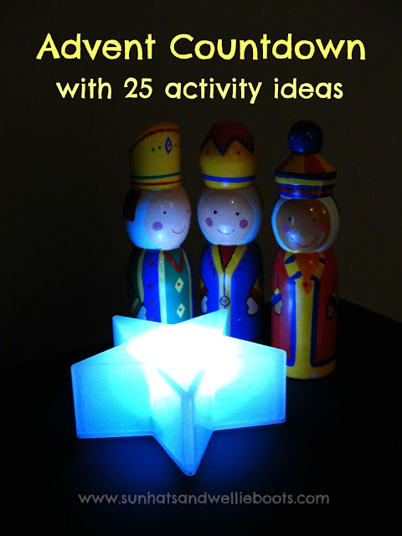
At the moment Minnie loves treasure hunts, hide & seek games, & anything which involves searching for clues. With this in mind & thinking also of the Christmas story (Mary & Joseph searching for a place to stay & the 3 Kings searching for a star) it was clear our Advent Calender needed to be interactive.
Every year we have a wooden toy stable & set of Nativity figures (which include the 3 Kings) out for her to play with. At the beginning of Advent we set up the empty stable with just the animals & the empty manger.
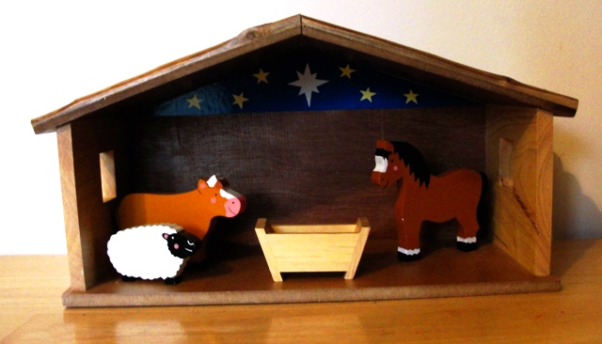

For a change this year from December 1st - 25th, the 3 Kings are going on a treasure hunt! Obviously, the treasure they're seeking is the newborn King, but from December 1st onwards their daily hunt will be to find the star which will be hidden somewhere around our house.

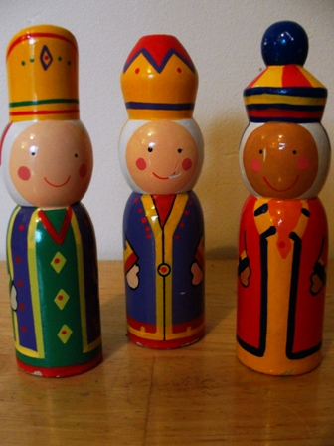
We wanted our star to light up so we could use it day & night & this small battery-operated light was perfect. Any star decoration or ornament would work for this Advent activity.

Each evening I'll move the glowing star ready for Minnie to find the following morning. The idea is that when she has found the star she'll move the 3 Kings from where they've been the previous day to the new position of the star somewhere else in the house.
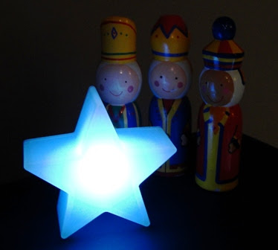

In the Nativity story the 3 Kings didn't arrive at the stable until after Jesus was born, & we could wait for Epiphany for them to arrive at our stable (on January 6th), but for this activity I think we'll move the star above the stable on Christmas night, so the 3 Kings visit Jesus on Christmas evening.
Attached to the star each day will be a piece of paper. On one side will be part of a picture, on the other side an activity for the day. I printed out a beautiful picture of the Nativity by Pauline Siewert & cut it into 25 pieces to create a puzzle. When we get to Christmas Day & all the puzzle pieces are together they'll create a beautiful picture. For me, it's quite poignant to leave this activity until the end of Christmas Day when all the hullabaloo of presents, dinner, games & celebrations have taken place.

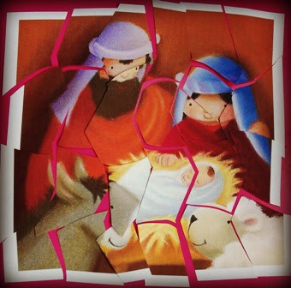

I have an envelope stuck to the back of our kitchen door to keep all the puzzle pieces safe, along with a large blob of white-tac! We'll stick our puzzle pieces onto the other side of the door, ready to arrange on Christmas Night.

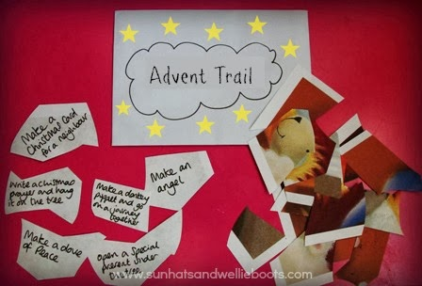

To help Minnie explore the real wonder of Christmas we've included these activities. Some link directly to the Christmas Story, & others encourage generosity & care.
Our activities this year are:
1. Make an Angel (& explore where they appear in the Christmas Story).
2. Make a Christmas card for a neighbour
3. Bake Christmas cookies & leave on someone's doorstep
4. Phone/Skype a long-distance relative & sing a Christmas song together.
5. Make a sheep to remember the shepherds (read about the shepherds in a Children's bible Luke 2:1-20)
6. Make a crown to remember the 3 Kings on their journey (read about the 3 Kings in a Children's Bible)
7. Go stargazing & see if you can see the brightest star in the sky!
8. Feed the animals/birds in the garden (& remember the donkey & other animals in the Nativity story)
9. Cuddle up & read a Nativity storybook by the lights of the Christmas tree before bed
10. Make a dove of peace to hang in the house (& say a prayer for peace in the World)
11. Make a gift for a friend
12. Invite friends round for picnic tea (reflecting hospitality & welcome at Christmas)
13. Light a candle to remember someone special (look at how the light of the candle brightens the darkness)
14. Make/buy sweet treats for someone living on their own (remembering the 3 Kings & their gifts)
15. Dress up as a Nativity character
16. Decorate the toy stable & add the Mary & Joseph figures
17. Make a card for a family member telling them why they're special
18. Go to a carol service
19. Write a Christmas prayer/wish & hang it on the Christmas tree
20. Decorate our Advent / Christmas tree
21. Invite an elderly friend to share the Christingle service with us.
22. Make a donkey puppet & go on a journey together around the garden/park
23. Invite your Mary & Joseph figures to sit with you at your dinner table & share a meal
24. Wrap a special present under the tree for Daddy
25. Happy Christmas Jesus is born! Sing happy birthday to Jesus!

