Abraham’s Family Tree
Complete the family tree below, noting the Scripture passage that mentions the birth or relationship of each person, as done for Ishmael.

Abraham

Hagar

Sarah

Isaac

Ishmael
Genesis 16:16

Esau

Rachel

maidservant
maidservant

Simeon

Dinah

Asher

The Patriarch Family Tree

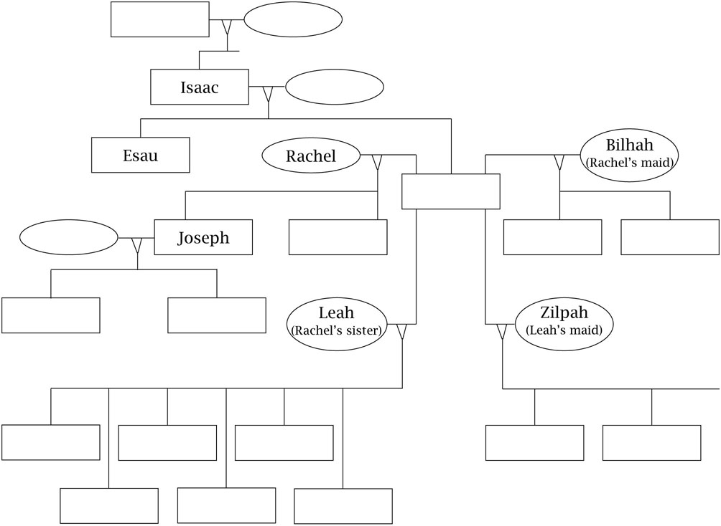

(Adapted from “My Own Genesis,” in Faith Works for Junior High: Scripture- and Tradition-Based Sessions for Faith Formation, by Lisa-Marie Calderone-Stewart [Winona, MN: Saint Mary’s Press, 1993]. Copyright © 1993 by Saint Mary’s Press. All rights reserved.)

