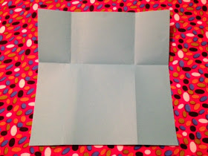
ACTIVITY: Who Do Men Say That I Am?
Materials needed: Paper/thin card, scissors, crayons.
- Fold paper down about a third. Do not unfold.
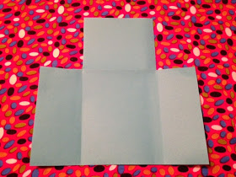
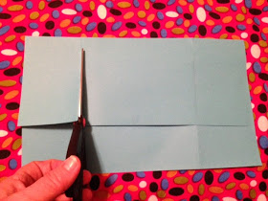
Fold sides of paper equally into the middle. Unfold.

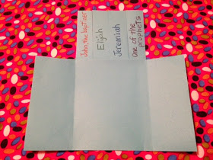
- Cut out the top rectangles that are opposite each other, cutting only the top folded-down paper, not the bottom paper.
- Cut four strips on top section of paper.
Write one name, "John, the baptist," "Elijah," "Jeremiah," and "A prophet", on each strip at top. (The disciples' suggestions)
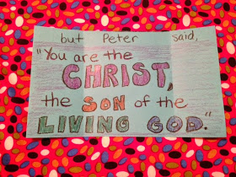
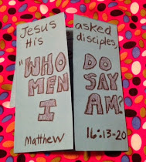
- Write "You are the CHRIST, the SON of the LIVING GOD." In the bottom section across the three sections. Close the bottom flaps.

- Write "Jesus asked His disciples, 'Who do people say that I am?" and "Matthew 16:13-20" across both flaps.

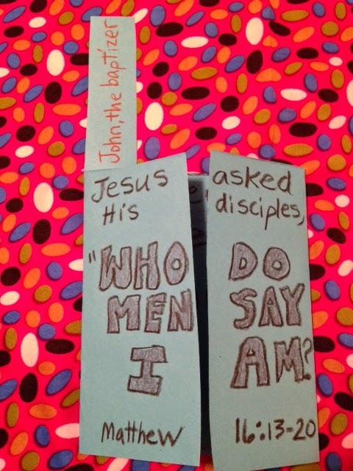
- Fold down all of the suggestions towards the back of the paper, so they cannot be seen from the front view. Closing the front flaps, read the title. Then, as the suggestions of who people thought Jesus was are said aloud, each suggestion is held up. Like this >>>

One by one the names are read then folded back down so they cannot be seen. In the end, the front flaps are opened with Peter's correct response!

Jesus is the Messiah (or Christ – the same word)
The Son of the Living God

