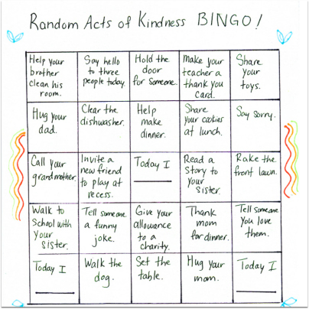
Random Acts of Kindness Bingo
Kids understand the concept of being kind, but sometimes they have difficulty knowing how to put the concept into action. Play this ongoing game around the house so they have easy options at hand all the time.
What you need: paper, pencils, crayons or markers; bingo stampers or highlighters.

What to do:
- Make a grid on a piece of paper. Make as many squares as you wish but sixteen or twenty-five work well. For very small children, nine squares help to achieve a “Bingo” a little more quickly.
- The kids can decorate the Bingo sheet with images that come to mind when they think about kindness (hearts, rainbows, helping hands).
- In each Bingo square, write an act of kindness. Get your kids involved and encourage them to think up ways to be kind: say hi to a neighbour down the street, help younger sibling pour the milk, set the table without being asked, etc. Leave a square or two blanks for spontaneous acts of kindness that aren’t specified on the Bingo sheet.
- Make, decorate and cut out small hearts. Then, stick the hearts to the bingo board when the kids complete the acts of kindness. You could also stamp the square with a Bingo stamper or highlight it if you prefer.
- When the Bingo square is complete have some way to celebrate: a special dessert, or a half-hour later bedtime, for example.

