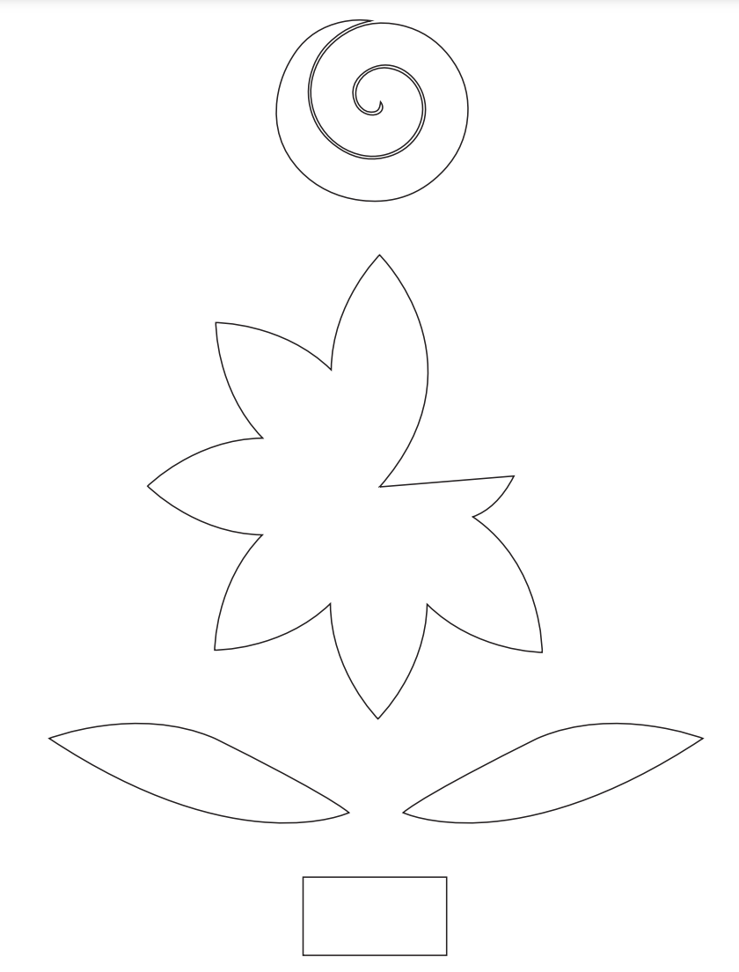

For instructions follow here:
https://www.easypeasyandfun.com/how-to-make-paper-daffodils/

