Thy Kingdom Come

2021 Prayer Journal colouring resources

These colouring resources are designed to use alongside the 2021 Thy Kingdom Come prayer journal, which may be downloaded for free:
https://www.thykingdomcome.global/resources/new-2021

For each of the 11 days of prayer, there is a decoration to be coloured, based on the reading and reflection in the prayer journal. A blank set of decorations is included for those who would prefer to draw their own. They can be cut out and displayed on a prayer tree, or used as part of the journal – or in any creative way you like!

Feel free to copy, print and share the resources: where possible, I would appreciate being credited.
Enjoy,
Julia Quinn Rev Julia Quinn
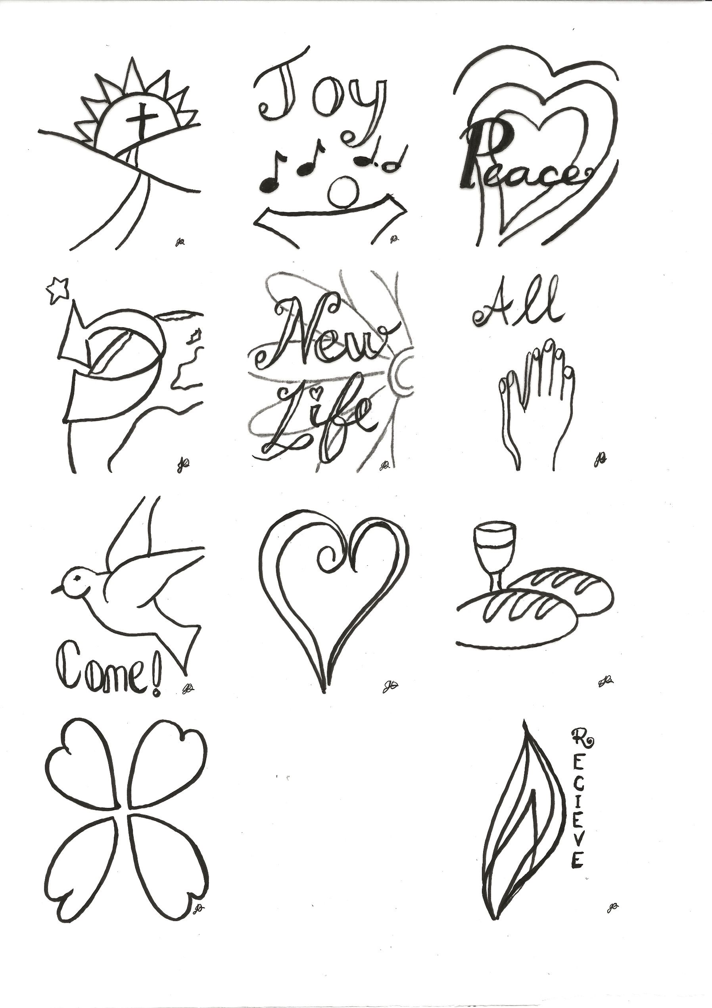
These images have been designed to accompany
Thy Kingdom Come’s Prayer Journal 2021

Created by
Julia Quinn
3
2
1

4
6
5

9
8
7

10
11

Blank for you to create your own images for
Thy Kingdom Come’s Prayer Journal 2021

Created by
Julia Quinn

